Compacting Outlook Mail File

Compacting your mail file for Microsoft Outlook is not only tidy - it also saves space (and a little time). Before starting it though, you should be aware that this process can take a while - easily 6 hours, sometimes more, depending on the size of the mail box and folders.

1. Load up **Microsoft Outlook**.
2. Point to **File** on the menu and click on it.   
   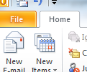
3. Click on **Account Settings** and then again when the drop-down menu comes up.   
   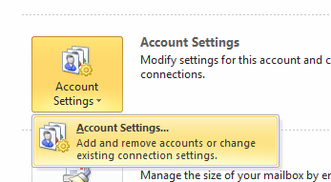
4. When the dialog box pops up, click on the **Data Files** tab.   
   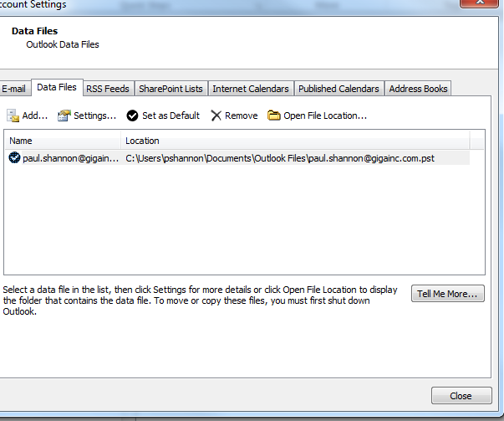
5. Next, click on **Settings**.   
   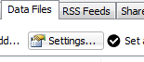
6. Finally, click on **Compact Now**. This process can take anywhere from a few minutes to several hours.   
   